The Facilities Monthly Report serves as a comprehensive and current repository of vital information pertaining to the building and plant maintenance program, encompassing a detailed overview of services and sustainability initiatives. Additionally, it encapsulates essential data related to related projects, events, deliveries, and work unit updates, all of which are strategically aligned to meet the specific needs and objectives of the campus. The report provides stakeholders with a succinct yet thorough glimpse into the ongoing operational dynamics, ensuring a holistic understanding of the facility management landscape.
Contents
Safety 2
Safety Report 2
Maintenance 2
Planned maintenance: 2
Unplanned Maintenance: 2
Unplanned Outages or critical equipment failure: 2
Budget: Unplanned Maintenance vs Planned Maintenance: 3
Project updates: 3
Building Services & Contractors 4
Contract Management: 4
Service Desk Task Summary: 4
Security and After-Hours call out log: 5
Loading Dock (QMK only) – Deliveries & Contractor Summary 5
Visitor Management System – Sine Pro 5
Sustainability 5
Initiatives: 5
Utilities: Comparative Reports 6
Gas Emissions 5 yr Comparative Report [source: Operations & Services, Arts Queensland] 6
Electricity Emissions 5 yr Comparative Report [source: Operations & Services, Arts Queensland] 6
Water Comparative Consumption Table – 5 years 7
Waste 5yr Comparative Report - [source: Operations & Services, Arts Queensland] 7
Training & Leave Report: 8

Safety

Safety Report
- Monthly Safety Report submitted by MS on 11th June 2024.

Maintenance

Planned maintenance:
- Regulatory work 100% completed for the month, includes Building, Fire Systems & Mechanical & Hydraulics.
- Industry Standard 100% completed for the month, includes Hydraulics, Mechanical & Occupant Emergency Program.
- Manufacturer Recommended 100% completed for the month, includes Equipment & Vehicle Maintenance.
- Owner Discretion 100%: completed for the month, includes Fire Systems, Hydraulics, Landscaping & Building maintenance.

Unplanned Maintenance:
- Café Muse.
  - Convotherm Combi-oven: New ovens installed 28th May. Working okay, osmosis cleaning unit needs GPO installed. BTP Electrical has quoted and approval to proceed given.
  - Pest issues reported – cockroaches in toilets and in food preparation areas. Rentokil quoted for and approved to go ahead for ‘123 Knockdown Cockroach treatment’. 2nd Wed of each month (additional to standard monthly treatment – 4th Wed of each month).

Unplanned Outages or critical equipment failure:
- BSP Lab walk-in freezer: Iced up on rear door. Repair required walk-in to be decanted. Temporary container freezer hired for service yard so Biodiversity team can decant. Honeywell have replaced door seals, door heating element and adjusted pressure in outside rooms. Still some seepage detected, door magnets have been ordered to install to better seal the freezer.

Budget: Unplanned Maintenance vs Planned Maintenance:
Year to date actuals – FYTD 2023/24.

10019 Facilties / Buildings & Grounds - YTD – Period: March 2024 | YTD Actuals
Maintenance
Planned Maintenance | $38,342
Unplanned Maintenance | $89,595
Total Maintenance Expenses | $127,937
% Planned Maintenance | 30%
% Unplanned Maintenance | 70%
Target | 65%/35%

Project updates:
- Dust Extractor Workshop – Issue with resetting frequently and emptying, and safety of this work. APaF has been notified, issue is being elevated to Director level & with Risk and Compliance.
- TBA

Building Services & Contractors

Contract Management:
Services Listing:
Service | Date: Previous Meeting | Date: Next Meeting | Minutes | E-File number | Contract Term
Mechanical | May 2024 | Tba* | Yes | D23/89350
Electrical | May 2024 | Tba* | Yes | D23/89350
Horticultural | 08/05/24 | 12/06/24 | Yes | QMN24/5
Cleaning | 08/05/24 | 12/06/24 | Yes | QMN24/5
Lift | May 2024 | Tba* | Yes | D23/89350
Security | 23/05/24 | 23/06/24 | tba
Pest Control | 08/05/24 | 12/06/24 | Yes | QMN24/5
*APaF is reviewing monthly meeting structure and dates

Service Desk Task Summary:
Total | Closed or Resolved | Remaining outstanding
52 | 36 | 0
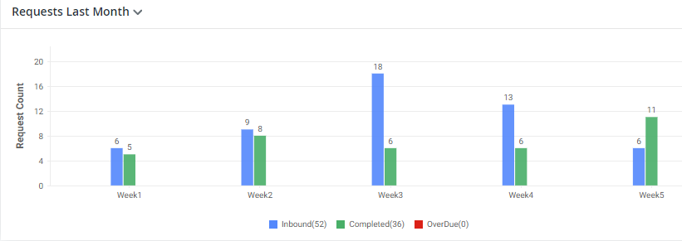

Security and After-Hours call out log:
Record D20/49960: QMN Facilities - Security Incident Register - 2019 2020 2021 2022 2023 2024
DATE | START TIME (24HR) | INCIDENT TYPE | DETAILS | ACTION
Wed, May 08, 2024 | 11:30 | Biological Hazard | Springmount contacted OS1 and advised they had discovered and discarded a used needle in the QM Level 2 public male bathroom | Removed by Springmount

Loading Dock (QMK only) – Deliveries & Contractor Summary
- 152 Deliveries
- 1 Contractor Site Induction
- 158 Contractor visits for the month

Sustainability

Initiatives:
- QCC Sustainability Action Group met 24th October 2023. QM Matthew Sansom & Frank Feige attended. See eFile: Record QMN23/4320: QCC Sustainability Action Group - Meeting Documents and Reports
  - Main outcome was discussion on Waste Measures and Reporting Proposal.
  - Next meeting 11th June 2024

Utilities: Comparative Reports
Note: Only reports up to March have been received. These were on previous report.

WASTE
Following are snapshots from Springmount Waste Report – April 2024

Training & Leave Report:
- Frank Feige, on planned Leave until Oct 2024

